
ICRRD Journal 2025, vol X, ISSUE x, XXX-XXX
ISSN: 2773-5958
https://doi.org/10.53272/icrrd
https://www.icrrd.com



TITLE OF THE ARTICLE (English) - Font TNR Font size 11, Uppercase, Bold

First Author^{1*}, Second Author², Third Author³ - Font TNR Font size 11

¹ Affiliation (School, University address, Country) - Font TNR Font size 9
²Affiliation (School, University address, Country) - Font TNR Font size 9
³Affiliation (School, University address, Country) - Font TNR Font size 9

*Corresponding Author Email: - Font TNR Font size 9, Italic

Received: XX XXX XXXX • Accepted: XX XXX XXXX • Published: XX XXX XXXX

Abstract

The manuscript should contain an abstract. The abstract should be self-contained and citation-free and should not exceed 250 words. The abstract should state the purpose, approach, results and conclusions of the work. The author should assume that the reader has some knowledge of the subject but has not read the paper. Thus, the abstract should be intelligible and complete (no numerical references); it should not cite figures, tables, or sections of the paper.

Keywords: Use about five keywords or phrases in alphabetical order, Separated by Semicolon.

Cite as: Authors (Year). Title of the article (in English only). Asian People Journal, X(X), XX-XX (APA Style)

INTRODUCTION

This document can be used as a template for Microsoft Word versions 6.0 or later. Do not submit papers written with editors other than MS Word; they will not be accepted for review. Save the files to be compatible with many versions of MS Word (avoid other document extensions than *.doc, *.docx, or *.rtf).

Only submit papers carefully spellchecking and checking the English language grammar. The style from these instructions will adjust your fonts and line spacing. Please do not change the font sizes or line spacing to squeeze more text into a limited number of pages.

PAGE LAYOUT

An easy way to comply with the paper formatting requirements is to use this document as a template and type your text. Your paper must use a page size corresponding to A4, which is 21cm wide and 29.7cm long. The margins must be set as follows:
Top = 1.3cm
Bottom = 1.5cm
Left =1.8cm
Right=1.5cm
Your paper must be in one-column format with a line spacing of 1.15.

The paper should have the following structure
1. Title of the paper
2. Authors and affiliations
3. Abstract
4. Keywords
5. Introduction
6. Methodology
7. Result and Discussion
7. Conclusion
8. References

PAGE STYLE

All paragraphs must be justified in alignment. With justified alignment, the paragraphs are straight.

Text font of the entire document
The entire document should be in Times New Roman. The font sizes to be used are specified in Table 1.

Title and author details
All title and author details must be in single-column format and centred. All titles must be capitalised. Author details must not show any professional title (e.g., Managing Director), academic title (e.g., Dr.), or membership in any professional organisation (e.g., Senior Member IEEE).
To avoid confusion, the family name must be written as the last part of each author's name (e.g., John A.K. Smith). Each affiliation must include, at the very least, the company's name and the country where the author is based (e.g. Causal Productions Pty Ltd, Australia). Email address is compulsory for the corresponding author.

Headings and subheadings
Headings should be limited to three levels. The main heading should be in bold, Times New Roman, 11-point font, and left-aligned, with each word capitalised. For Level 1 subheadings, use the same formatting (bold, Times New Roman, 11-point font, and left-aligned), but only capitalise the first letter of each word. Level 2 subheadings should be italicised, Times New Roman, 11-point font, left-aligned, with only the first letter of the first word capitalised. Avoid using more than three levels of headings to maintain clarity and consistency.

Table 1: Font Specifications for A4 Papers – (Font TNR Font size 11)

Font Size | Appearance (in Time New Roman)
Font Size | Regular | Bold
11 | Table caption, centred  Figure caption, centred
11 | Author’s affiliation, centred  Paragraph  Abstract body

Figures and tables
Graphs and other numbered figures should appear as close to their mention throughout the text as possible. Figures should not infringe upon the page borders.

Figures and tables must be centred in the column. Large figures and tables can be in one column to see them more clearly and avoid placing them in the middle of columns. Any table or figure that takes up more than 1 column width must be positioned either at the top or at the bottom of the page.

Photos must be crystal clear and have a resolution that allows fine details to be visible. The elements from any photo must be explained using numbers, letters, etc. The text within a figure or photo must have the same style, shape, and height as the caption.

Any table, figure or picture must have a caption (Figure 1, Table 1, etc.) followed by a proper description. All similar graphics must be generated using the same software product (Excel, Origin, Mathematica, etc.). Importing graphics into the article as images (JPG, BMP, PNG, etc.) should be avoided. All similar electronic schematics, charts, program flow, simulated characteristics, etc., from the article, should be generated using the same software product. Importing images from other articles or books is forbidden unless they are cited.

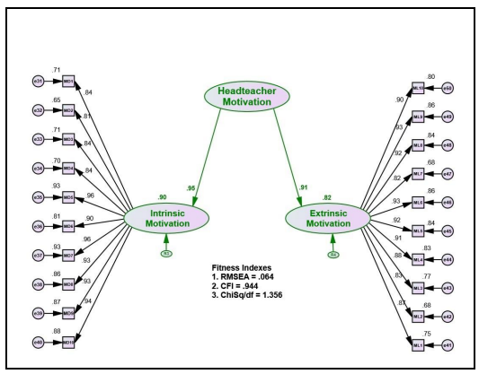
Figure 1: The text within the figure is Times New Roman, with an equivalent height of 10 points, as the caption is. All letters used in the figure are explained in the caption: L = patch length, W = patch width, Cd = cut depth, Cw = cut width, Fl = feed length, Fw = feed width.

Figure Captions
Figures must be numbered using Arabic numerals. Figure captions must be in 11 pt Regular font. Captions of a single line (e.g. Figure 2) must be centred. If the caption is longer and takes up multiple lines, it should be justified (aligned evenly on both the left and right). Captions and numbers should always be placed below the corresponding figure, as shown in Figure 1.

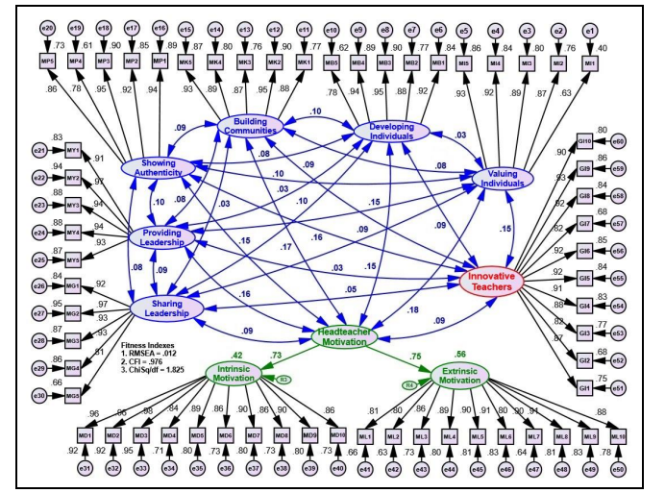

Figure 2: Example of an image with acceptable resolution

Table Captions
The captions for tables must be centered and in 8-point regular font. These captions, along with the table numbers, should be placed above the corresponding tables, as illustrated in Table 1.

Links and Bookmarks
All hypertext links and section bookmarks will be removed from papers while papers are being processed for publication. If you need to refer to an Internet email address or URL in your paper, you must type out the address or URL entirely in Regular font.

Equations
Equations should be numbered consecutively throughout the paper. The equation number is enclosed in parentheses and placed flush right, as in (1). Your equation should be typed using the Times New Roman font (please, no other font). To create multilevel equations, it may be necessary to treat the equation as a graphic and insert it into the text after your paper is styled.

(1)

Definition 2.1: This is a text of a definition.

(2)

Use the same symbol in a definition over the entire article. Use correct symbols for physical or technical terms. (Example: ε0 and not ε0 for permittivity). Do not repeat definitions throughout the article. Refer to already defined symbols, equations, and theorems using the cross-reference number (Example: As pointed in (1) the…).

A STEP BEFORE THE FINAL SUBMISSION

Detailed submission guidelines can be found on the journal web pages. All authors are responsible for understanding these guidelines before submitting their manuscript.

CONCLUSION

In this section, you should present the conclusion of the paper. Conclusions must focus on the novelty and exceptional results you acquired. Allow sufficient space in the article for conclusions. Do not repeat the contents of the Introduction or the Abstract. Focus on the essential things in your article.

ACKNOWLEDGEMENT

This is a text of acknowledgement. Do not forget the people who have assisted you with your work. Do not exaggerate with thanks. If your work has been paid by a Grant, mention the Grant name and number here.

REFERENCES (APA 7th Style)

Adam, I. (2019). Digital leisure engagement and concerns among inbound tourists in Ghana. Journal of Outdoor Recreation and Tourism, 26, 13-22. https://doi.org/10.1016/j.jort.2019.03.001
Axford, J.C. (2007). What constitutes success in Pacific Island community conserved areas? [Doctoral dissertation, University of Queensland]. UQ eSpace. http://espace.library.uq.edu.au/view/UQ:158747

Norton, M., Moloney, G., Burke, S., Sanson, A., & Louis, W. (2018, September 27-30). Psychological responses to social threats: From stigma to solidarity [Paper presentation]. 2018 APS Congress Psychology advancing into a new age, Sydney, NSW, Australia.

Rattan, A. (2019). How lay theories (or mindsets) shape the confrontation of prejudice. In R. K. Mallett & M. J. Monteith (Eds.), Confronting prejudice and discrimination: The science of changing minds and behaviors (pp. 121-140). Academic Press. https://doi.org/10.1016/B978-0-12-814715-3.00008-4

Swartz, W. (2019). Descriptive psychology and the person concept: Essential attributes of persons and behavior. Academic Press. https://doi.org/10.1016/C2017-0-00372-5

Whittingham, K., & Coyne, W. (2019). Acceptance and commitment therapy: The clinician's guide for supporting parents​. Academic Press. https://doi.org/10.1016/C2017-0-01265-X


This is an Open Access article distributed under the terms of the Creative Commons Attribution 4.0 International License (https://creativecommons.org/licenses/by/4.0/), which permits unrestricted use, distribution, and reproduction in any medium upon the work for non-commercial, provided the original work is properly cited.

